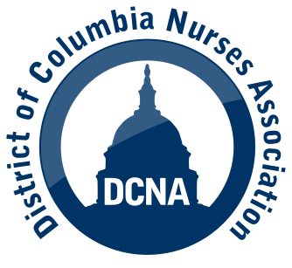

**DCNA & Howard University/Howard University Hospital**

**Contract Negotiations**

**Bargaining Bulletin # 3 – July 14, 2025**

* The parties resumed bargaining on July 11th and reached tentative agreement on 19 articles in the collective bargaining agreement.
* Staffing Committee: The Hospital proposed a more detailed structure and requires monthly meetings and information. The Hospital committed to having the highest level of management, including the CFO, CNO and Counsel, as management members on the Committee. The Hospital advised that it is committed to working with DCNA to address staffing issues. To view the proposal, please contact a DCNA bargaining team member.
* Compensation: The Hospital proposed the following:

Wage increases:

* Year 1 - restore step increases; no raise
* Year 2 – step increase; 1% wage increase; 2% premium pay for RNs regularly assigned to: Emergency Dept., Wound Care, OR, L and D, Cardiac Cath, NICU, MICU & SICU.
* Year 3 – step increase; 1% wage increase; 5% premium pay (same units)
* No other increases in compensation (leave, parking, df pay, etc.)
* DCNA and the Hospital agreed to extend our collective bargaining agreement through August 13, 2025.

DCNA Bargaining Team Members:

Eileen Shaw, President Jacqueline Lewis, VP Dharra Antani

[eshaw@huhosp.org](mailto:eshaw@huhosp.org) [jlewis@huhosp.org](mailto:jlewis@huhosp.org) [dantani@huhosp.org](mailto:dantani@huhosp.org)

Michele Jones, Exec. Bd. Kimeera Rao, Exec. Bd. Edward J. Smith (DCNA)

[mijones@huhosp.org](mailto:mijones@huhosp.org) [krao@huhosp.org](mailto:krao@huhosp.org) [esmith@dcna.org](mailto:esmith@dcna.org)

Rey Punsulang, Exec. Bd. Jean Kitongo

[rpunsulang@huhosp.org](mailto:rpunsulang@huhosp.org) [jkitongo@huhosp.org](mailto:jkitongo@huhosp.org)

Marie Ongobabouli Sade Martin

[MOngobabouli@huhosp.org](mailto:MOngobabouli@huhosp.org) [smartin@huhosp.org](mailto:smartin@huhosp.org)